Worksheet: Educate Your Users with Conversational Bumpers

Step 1: Segment Your Emails By Customer Jobs

Select one Customer Job that your product solves. In the future, you can create different onboarding email flows based on other types of customer jobs.

Step 2: Create a Behavior-Based Email Flow
Using a tool like Trello, Notion, or Excel, map out your behavior-based onboarding email flow. If your user doesn’t complete a step, try to understand if it’s because of a lack of motivation or ability. Talk to your support team to figure out what are the common questions or requests you get from new users.

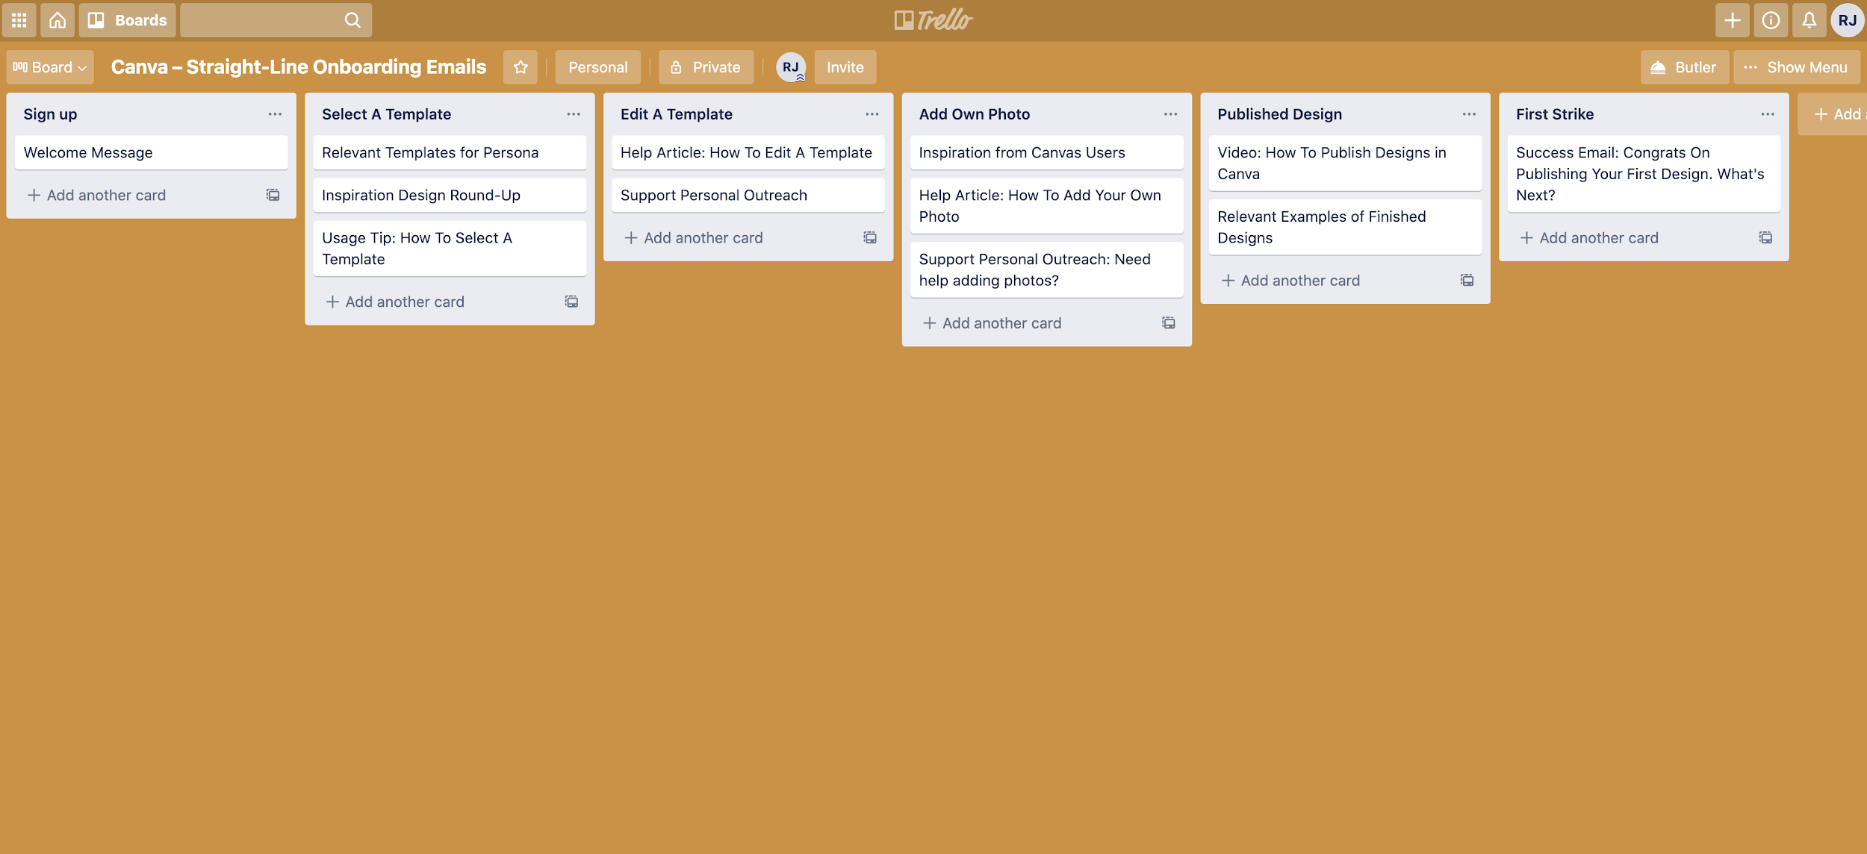

Step 3: Fill In The Details For Each Email
Write in the details for each email. Below are templates you can use:

Welcome Messages
New users expect a welcome email. That’s why it has typically one of the highest open rates at 60 percent or more.

Subject | a personal hello 🙂
Body | Hey,  I'm one of the co-founders of [Your Company] and I'm excited  you've decided to sign up.  The [Your Company’s Name] Team and I have poured our heart and soul into making [key outcome your product solves for] suck less, so I get really fired up when someone new, like you, joins the ranks.  My top priority is to make sure you’re able to {insert value proposition], so if you have any questions about our product, the website, or even my lackluster  mustache, feel free to reply directly to this email.  I hope you able to [accomplish key outcome in product]! Stay in touch 🙂  P.S. Yes, I'm a real human.  - Wes, Co-Founder

Better Life Messages
Better life messages focus on communicating the functional, emotional, or social job of your product. How will your product make the user’s life better?

Subject | you’re in -- [ company name ]
Body | Hey, thanks again for checking out [ company name ] (we help you [  <5 word summary of what you do ] ).  - Customer benefit 1 (“You don’t have to worry about X anymore”)  - Customer benefit 2 (“You can finally actually achieve Y, and in less time”)  - Customer benefit 3 (“It’s free for the first month” / statement on value received)  But, none of that’s going to happen if you don’t get started 🙂  ==> CREATE YOUR FIRST DASHBOARD HERE <== (your action-worded  CTA)  Talk soon,  Wes

Sales Touches
As the name implies, sales touches are when sales reaches out to users. These emails can be automated, but the most important part here is timing.

Subject | [Intriguing phrase about how a paid feature will make their lives easier. E.g…
Body | Hi {{user.first_name | capitalize | default: "there"}},  [Pain point referenced in subject line] is no fun. [Describe a few problems the pain point causes. E.g., keeps them at the office late in the evening, forces them to delete important files or scatter them across multiple locations, wastes precious hours each week preparing for meetings and then having to reschedule.]  With [paid feature], you’ll [get huge benefit. E.g., have the freedom to take Friday afternoons off, rest easy knowing their files are all in one place, increase productivity by 18%].  Since [paid feature] is part of our [paid plan name] plan, you’ll just want to upgrade to [paid plan name] and you’ll be good to go!  Sounds great. Take me to my Billing page now, so I can start [getting benefit] [link].  Talk soon,  [Signature]

Usage Reviews
Usage review emails showcase the value of your product. These emails should far outlive your onboarding experience as they remind people why your product is valuable.

Subject | Your [Product] weekly activity report
Body | Hi {{user.first_name | capitalize | default: "there"}},  [Statement about what they accomplished with your product. E.g…  Here’s how many tasks your team accomplished last week  Here’s the current status of your proposals (drafted, sent, and accepted)  Here’s how many hours of work [Product] saved you last week ]  [Activity section. Rule of thumb: only show activity that will make your user feel accomplished. A good barometer: is it activity they’d feel proud of, or want to show to their boss? If so, it’s probably good activity to show. E.g…  - Number of new proposals sent  - Number of new proposals accepted  - Increased productivity  - Increased traffic  - Increased engagement with their content or product  - Increased sign-ups or revenue ]  - Happy [verb your product does]ing!  - Signature

Better Life Emails
Better Life emails focus on communicating the benefits of the product.

The main CTA in these emails will often be to upgrade an account, however, they can also be used to direct people to try specific features out on their own.

Better Life emails are different than case study emails in that it doesn't rely on you to tell a customer's story but can simply focus on communicating the benefits of the product.

For Twist, they use Better Life Emails to encourage people to "take back the workday" and sign up their team.
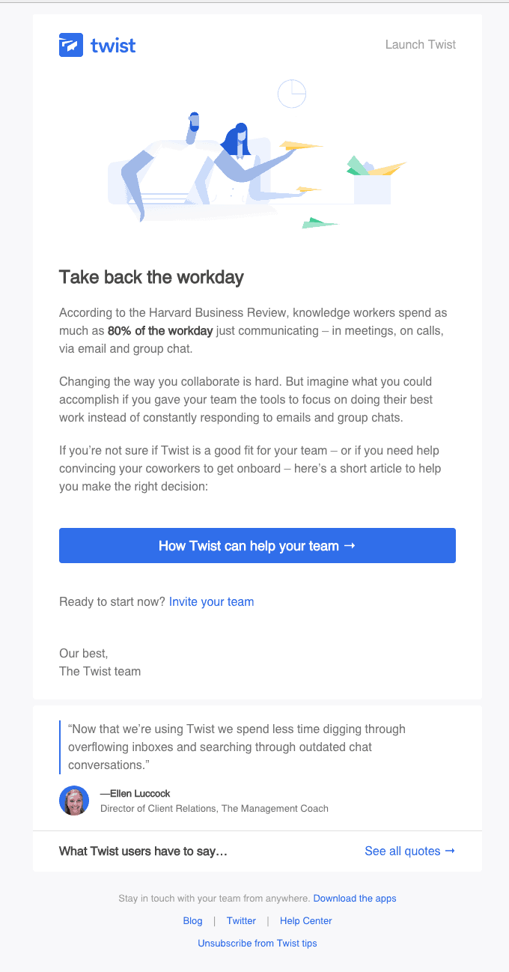

Expiry Warning Emails
Expiry warning emails remind the user to upgrade before the free trial ends.

Typically expiry warning emails are used for free trials. Freemium models don't typically use expiry warning emails because you are giving away part of the product away for free forever. With that being said, if you have a hybrid freemium model where you combine both free trial and freemium models, expiry emails can be used to motivate users to upgrade.

For Squarespace, they send out expiry emails to notify users that their trial is going to expire soon. What's great about this email is that they reinstate the value proposition and why it makes sense to upgrade now.
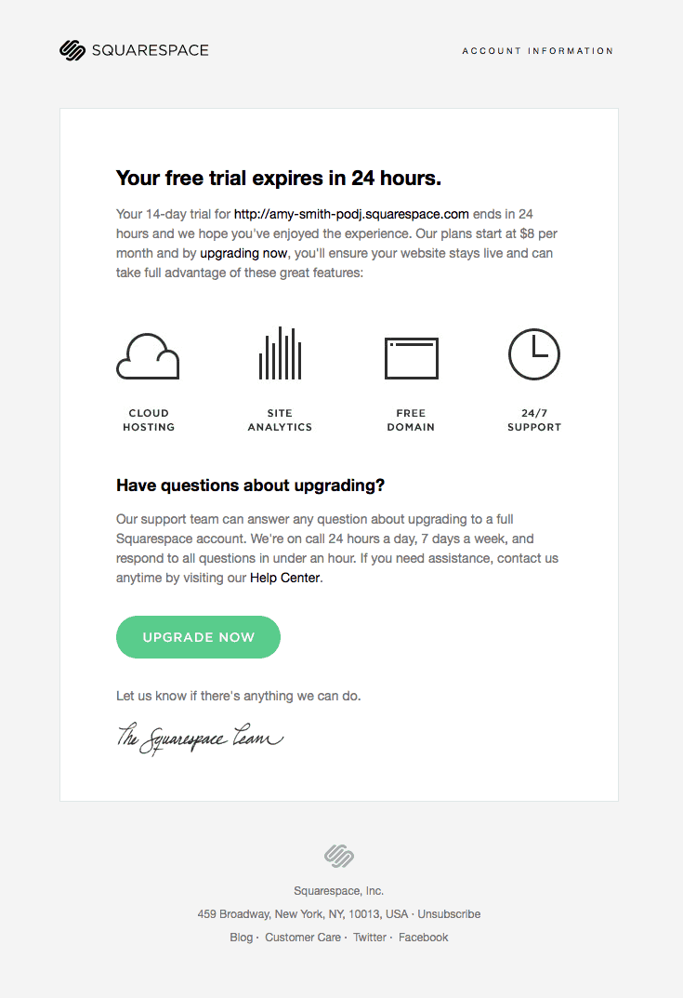

Expiry Warning Emails
Whether it's sending a case study email that includes a video testimonial, customer story, or case-study, you need to showcase your customer's results from using the product.

For Invision, they do this by showcasing some of the incredible designs their customers have created through using the product.
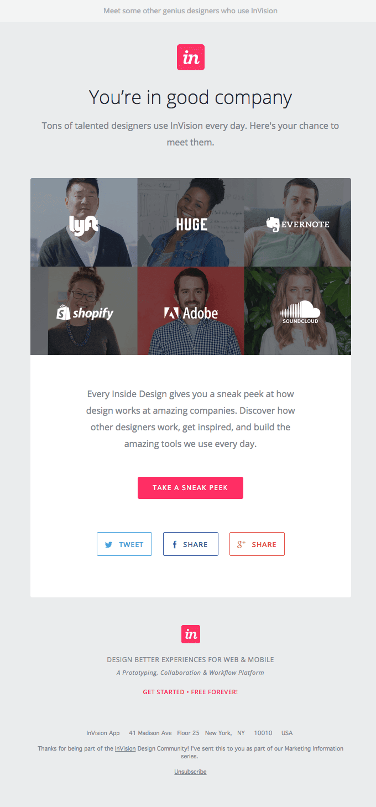

Usage Tips
Usage tips are helpful nudges that direct users to take steps in the product that will set them up for success.

One thing to keep in mind when using usage tip emails is that you should be careful what activity you encourage. For instance, if the activity you're encouraging users to take isn't lined up with experiencing meaningful value in the product, you risk losing the user's motivation.

In general, your usage tip emails should do these three things:

- Direct users to a specific in-app page (e.g. “Manage users” page)
- Link to specific help center articles or blog posts (e.g. “how to invite a user from outside your company”)
- Give actionable best practices, or invite abandoned users back
- If you can do these three things, you'll be in a better position to help your users become successful.

A perfect example of a usage tip is from Wistia's Soapbox product. As soon as I created my first video, they sent a usage tip email to encourage me to share it with someone.

